The Challenges and Opportunities in Multiculturalism

Vincent N. Parrillo
William Paterson University

When the American songwriter, Bob Dylan (1941- ), composed and recorded The Times They Are A-Changin’ in 1964, his lyrics succinctly captured the spirit of the political and social turbulence of the 1960s in the United States. It was a decade filled with social movements (civil rights and women’s rights) and challenges to the social order (the Hippie counterculture and the anti-war protests). It was also a time of violence (urban riots and assassinations) and radicalism (Black Panthers and the Symbionese Liberation Army). During this chaotic period, the activists and the members of the establishment blamed each other for the unrest and instability.
Although it is quite natural for individuals to view changes around them from a personal perspective, the American sociologist C. Wright Mills (1916-1962) informed us, “Neither the life of an individual nor the history of a society can be understood without understanding both.” He emphasized that most individuals do not understand that their personal troubles exist within the framework of larger public issues. Using our sociological imagination, he said, enables us to grasp this intersection of history and biography, and how the two interrelate within society. The classic social analyst thus recognizes the need to approach social phenomena in this way, for doing so increases one’s potential to discover promising insights into the social dynamics of life.
Both Dylan and Mills provide a relevant framework for an examination of our times. This decade may lack the turbulence and violent clashes that existed in the 1960s, but today’s economic and social upheavals in developed countries—brought on by globalization, migration, and dramatically changing demographics—are so momentous that they produce other kinds of anxieties among the populace. So Dylan’s song is an appropriate anthem for these times as well. Moreover, these social forces spawn concerns about the retention of a national culture and identity, as well as maintenance of societal cohesiveness. Today, many people worldwide have not heard of Mills and his concepts, but they are nonetheless keenly aware of a relationship between their personal troubles and the larger forces at work in the world. They bear witness to the increase of foreigners in their midst, the breakdown of national borders through the Internet, and that their lives are increasingly interconnected with other parts of the world.
Globalization has shrunk the world irrevocably. Practically everyone everywhere is now cognizant of the diversity of people and cultures elsewhere. Foreign lands no longer seem so remote, prompting in many the desire to travel or migrate. Multinational companies are the norm, as are transnational families maintaining strong links to their homeland even while building new lives in their adopted country. Despite their inevitable adapting to their new culture, technology allows immigrants to retain their own multicultural reality through a psychological nearness to others they left behind, as well as through the reinforced ethnic vitality they experience among compatriots who have made the same migrating journey
In this still-evolving new world order, multiculturalism is not just a subject of interest in, and about, immigrant-receiving nations such as Australia, Canada, the United Kingdom, and the United States. Now, countries in Asia and Europe, once the locales of ethnic homogeneity, are experiencing internationalization. Italy, for example, now has more than five million legal immigrants and perhaps as many as two million more undocumented immigrants, putting its foreign-born population at 7.5 percent of the total. Japan now has more than two million immigrants, accounting for 1.6 percent of the total population. Similarly, the Republic of Korea finds its residential population becoming more and more international. Two powerful social forces—globalization and demographic trends—are spreading multiculturalism, topics of great interest to many Korean and American social scientists. Therefore, it is important to highlight some demographic data for us to understand multiculturalism in a social context.
Demographic Factors
Analysis of demographic trends enables us to envision the multicultural futures of the Republic of Korea and the United States. Although we can’t always accurately predict the future, we do invent it by our decisions and actions, because they create the social world that the next inherits. As the English playwright William Shakespeare wrote hundreds of years ago, “What’s past is prologue.” Today’s realities can suggest tomorrow’s possibilities.
Birth Rates
Total fertility rate (TFR) is one of the most popular measurement tools in demography. It refers to the national average for the number of births per women of child-bearing age. A nation that sustains a 2.1 TFR over a 55-year period has achieved zero population growth (ZPG). Anything above that number means that the population is increasing, and numbers below 2.1 indicate eventual population decline.
The U.S. had been below ZPG since 1972, but its present 2.12 TFR puts the rate slightly above replacement. Actually, the birth rate among native-born women remains below 2.1, but a higher birth rate among foreign-born women has put the national TFR at its present level. Thus, immigration is having a greater effect on U.S. population growth than in past generations.
The current 1.2 TFR in the Republic of Korea places the country sixth in the world for the lowest rate of natural increase. Although that rate is actually higher than the 1.08 rate in 2005, the country has been below ZPG since the 1980s. Many Korean women now marry later or choose to remain single to pursue a career. Consequently, such a sustained low TFR signals a future with substantial population decline and a rapidly aging population.
Population Pyramids
The dramatic decline in Korean births is reflected in the portion of those under 35 years of age shown in Figure 1. This graph offers a striking image of the population in Korea. Easily seen are the greater numbers of people between 30 and 60 years of age in each five-year grouping compared to those under age 30. Given its low birth rate and people living longer, the Republic of Korea is experiencing a significant increase in the median age of its population. Right now though, it ranks 54 in aging populations with a median age of 37.3 (males 36.0 and females 38.5). From a median age of 19.0 in 1970, it climbed to 27.0 in 1990. Demographers project that it will rise to 53.7 by 2050.
Figure 1 Age Structure of South Korea and the United States in 2010 by Gender

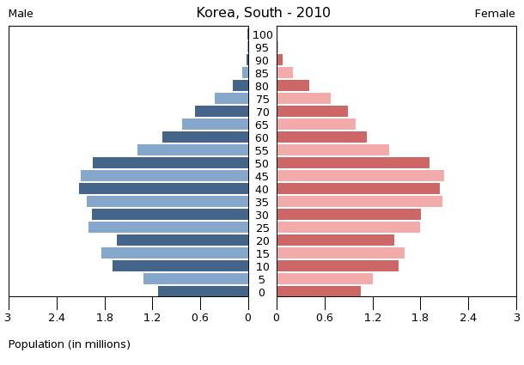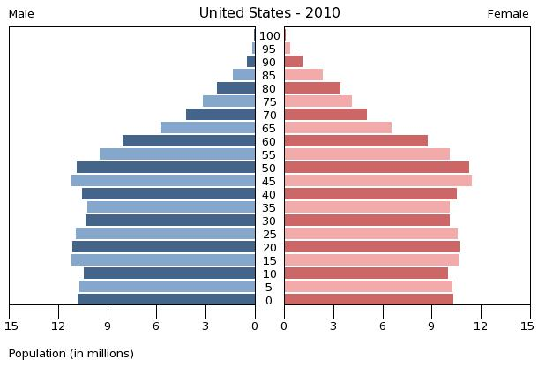
Median age: 36.6
Median age: 37.3
Source: U.S. Census Bureau, International Data Bank

In contrast, the above graphic for the U.S. population shows a fairly even, rectangular, distribution in the United States of persons under age 60 for each five-year classification. This is consistent with its hovering around the 2.1 TFR replacement ratio since 1972. However, because of greater life expectancy, its median age is also increasing. The U.S. median age of 30.0 in 1950 dropped to 28.2 in 1970, then rose to 32.8 in 1980 and today stands at 36.6 (males 35.4 and females 38.0). By 2050, the U.S. median age may be 41.7.
Figure 1 illustrates current age structures that resulted from past birth rates. Similarly, Figure 2 extrapolates current birth rate trends to give the medium-range projections for the mid-century. Unlike in the United States, Korean society will be “top-heavy” with an aging population because its births are so far below the replacement level. The number of people age 65 and older reached 5.2 million in 2009, which constituted 10.8 percent of the total population compared to 5.6 percent in Vietnam.
Figure 2 Age Structure of South Korea and the United States in 2050 by Gender
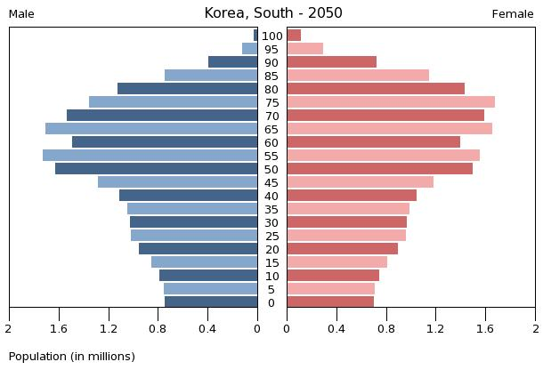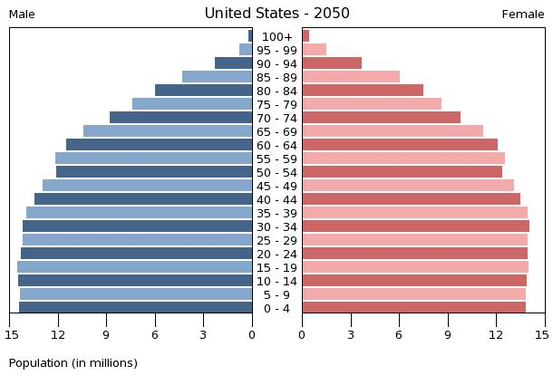
Median age: 53.7
Median age: 41.7
Source: U.S. Census Bureau, International Data Bank

By 2025, the U.S. population will increase from 306.8 million in 2009 to 357.5 million and to 439 million in 2050, thereby maintaining the country’s position as the world’s third most populous country (behind China and India). As is the current pattern, most of this growth will come from immigrants and their immediate descendants.
The 48.7 million in South Korea in 2010 continues sustained population growth throughout the twentieth century. However, given the low TFR, the population will eventually decline. Current projections show steady increases until reaching a peak of 49.1 million in 2025, and then an ongoing decline to 42.3 million by 2050.
As South Korea’s population continues to age and an increasing proportion reach retirement age over the next several decades, its native-born labor force will shrink. Indeed, the Korea National Statistical Office (KNSO) reported in 2005 that the nation's labor force ranging from ages 15 to 64 will begin to fall in 2016 and drop below half of the entire population by 2050. With a greater proportion of Koreans inactive, the dependency ratio between active and retired workers will increase. This not only will have an effect on the old age pension program, health care costs, and other social services. It will also impact heavily on the economic system. Raising the retirement age and removing barriers facing older workers seeking employment are two approaches Korea and other nations facing an aging population have taken or plan to take.
Even so, an expanding economy requires the availability of a larger labor pool than the current number. Even a stable economy demands sufficient replacements for new retirees to maintain stability. When natural population growth is insufficient to meet labor needs, countries must turn to an immigrant supply to meet the shortfall.
Foreign-Born Population
The Ministry of Public Information and Security reported in May 2009 that the number of registered foreigners had exceeded one million for the first time, a 24 percent increase over the previous year. The actual number, 1.1 million, constitutes 2.2 percent of the total population, but if illegal aliens are included that number is even higher. Chinese nationals, including Korean-Chinese, are more than twice the size (56.5 percent) to the next largest foreign-born group, the Southeast Asians, particularly Vietnamese and Filipinos (21.2 percent). Americans, Taiwanese, Japanese, and Mongolian nationals also constituted sizable portions of the foreign community.
The United States has about 38.1 million foreign residents, mostly Asians and Hispanics. This is about 12 percent of the total population. The total population, native- and foreign-born combined, is 66 percent non-Hispanic white; 15 percent Hispanic; 13 percent non-Hispanic black; 5 percent Asian and Pacific Islander; and 1 percent American Indian and Alaska Native. These are substantially different proportions than in 1990, when blacks were the largest minority group at 12 percent, Hispanics comprised 9 percent, and Asians accounted for 3 percent.
Two push factors—higher birth rates and economic deprivation in the sending countries—and the pull factor of economic opportunities in the receiving countries are the main driving forces that are increasing these foreign-born populations.
Impact on Society
The United States, always a nation of immigrants, has now become far more culturally and racially diverse than at any time in its history. In 2007, about 22 percent of all U.S. children under age 18 had at least one foreign-born parent. If current trends continue, by 2050 in the United States its foreign-born, now at 12 percent, may be 15 percent by 2040 and its minorites, now about one-third of the total population, will be the majority. That suggestion is a bit deceptive, however, since Hispanic is an ethnic classification and two generations hence many will be fully assimilated, and thus not really part of a minority group. Still, using Census Bureau data, Figure 4 shows Hispanics may increase to 31 percents, blacks to 16 percent, Asian and Pacific Islanders to 8 percent, with Native Americans remaining at one percent and non-Hispanic whites declining to 43 percent.
The Republic of Korea, for long a homogeneous nation, is becoming far more culturally diverse than at any time in its history. Significantly, it is not just the presence of foreign workers in industrial suburbs filling labor needs. International marriages are dramatically increasing and having a particular impact on rural communities. In 2000, for example, they were just 3.7 percent of all marriages in Korea, but by 2005, their proportion had increased to 13.6 percent.
The greatest impact of these still-increasing marriages has yet to be realized as the next generation of mixed ethnic heritage is born. Numbering only 35,000 in 2007, one study shows that the multicultural population will rise to almost 1.7 million in 2020, at which time one of three newborns and one of five youth under 20 in Korea will be multiethnic. Clearly, the country is changing from an ethnically homogeneous one into a multiethnic society in which a hyphenated Korean (Vietnamese-Korean or Filipino-Korean) will be as common as Korean-
American is today in the United States.
The question, “What is a Korean?” once posed an easy answer when the distinguishing marks of a relatively homogeneous population were only regional and subcultural differences. Today, however, the population is less homogeneous and that once easy answer no longer fits so easily, given the immigrant influx and growing numbers of Koreans marrying non-Koreans. The number of marriages between South Korean men and foreign women nearly quadrupled from 6,945 in 2000 to 28,163 in 2008, while South Korean women’s international marriages nearly doubled, increasing from 4,660 marriages to 8,041.
Perhaps it would be help in understanding better this new reality of multiculturalism by use of the metaphor of the rose.
Roses and Thorns
Cultivated for almost 5,000 years, roses were known to ancient civilizations in both Asia and Europe. One of the world’s most popular flowers, the rose now comes in more than 8,000 varieties. Yet as beautiful and romantic as most people find roses to be, their thorns can hurt.
Roses are an apt analogy in any discussion about multiculturalism. Both require warmth and nurturing to bloom fully. The stronger their roots, the more they thrive. Both have varieties of species, yet universal treatment gives vibrancy to all. Both also contain beauty and danger. Focusing only on the rose when reaching for it can bring flesh into painful contact with a thorn; focusing narrowly on racial or cultural differences often causes the pain of isolation or conflict.
Some proponents of multiculturalism (the separatists) want to focus on only one variety of “rose” among many, whereas other multiculturalism advocates (the inclusionists) stress the commonality in origin that the varieties of “roses” share. The third group of multiculturalists (the integrative pluralists) emphasizes the overall beauty of “roses” of different colors and varieties sharing the same “garden.” Critics of multiculturalism, however, seem only to see its “thorns.”
Completely ignoring the thorns needlessly places one at risk. If we look only at the thorns, we miss the beauty of the rose. If we pay heed to the thorns or remove them, as florists so thoughtfully do for their customers, they cannot hurt us, and our appreciation for the rose remains unspoiled. Let me continue with this metaphor, first with comments about the thorns, the negative side of multiculturalism, and then about the roses, the positive side. I speak here of the general patterns worldwide, some of which may apply less fully to a country such as the Republic of Korea than they would elsewhere.
The “Immigrant Thorns” Large-scale immigration fuels debate about multiculturalism because this subject is about more than preserving one’s heritage. It is about power struggles among groups. It is about economics, jobs, social welfare, and tax dollars. Concern about large numbers of immigrants arriving each year in any country, already multicultural or coming so, can generate a backlash from native-born citizens. If multiculturalism thus means favoring an immigration that brings dramatic demographic changes, then many people oppose multiculturalism.
The “Language Thorns” Newcomers speaking a foreign language have been a thorn in the side of many people, especially Americans. Language is the foundation for communication and interpreting one’s world. Inability to speak the native language is thus a barrier to social inclusion and interaction. As such, it provides fertile soil for suspicion, misunderstandings, and rejection of the outsiders. If multiculturalism thus means groups do not give a priority to proficiency in the country’s primary language, then many people oppose multiculturalism.
The “Cultural Thorns” Large numbers of new immigrants arriving in a short period of time slow acculturation and enhance ethnic resiliency in language, ingroup solidarity, and subcultural patterns. These immigrants usually live in the community but they are not of it, because they tend to interact less with neighbors and more within their own group. Often the wife, filling the traditional gender role as nurturer, has limited language proficiency and feels insecure about conversing with neighbors. The husband is usually at work for long hours and has little free time for community involvement. If multiculturalism thus means maintenance of an alien culture and lessening of community cohesiveness, then most people oppose multiculturalism.
The “Racial Thorns” Few talk openly of race in their opposition to multiculturalism even if racism is the unacknowledged motivation. Institutional racism—the established laws, customs, and practices that systematically reflect and produce racial inequities in society—is a more significant factor than individual racist actions, however. Biases in the social structure can cause individuals unknowingly to act without deliberate intent to hinder a racial group’s advancement. Pervasive racism is both an obstacle in the path of upward mobility to many racial minority group members and a basic impediment to better interracial relations. If multiculturalism thus means an increased racial presence and/or increased racial power that puts their own racial group to any disadvantage, then most people oppose multiculturalism.
The “Roses” of Multiculturalism
Roses bud, bloom, and fade away. Rosebuds give us the promise of new beauty about to arrive, and, when the flowers are in full bloom, their contribution of beauty to our lives has to be experienced to be fully appreciated. Gradually, however, the roses fade and their petals gracefully fall to the ground, covering the dark earth with their pastel colors. With modest pruning, the gardener can coax other roses to appear and repeat the process again and again.
Multiculturalism, however, is not a rose that will fade away in such countries as the United States, which has always been a land of diversity and destination for millions of immigrants. However, some “blooms” of ethnicity do fade away as, for example, what is called “the twilight of ethnicity” among European Americans. Moreover, what appear to some people as thorns may actually be roses instead. Let us extend our metaphor of roses onto the four types of thorns just discussed.
The “Immigrant Roses” If a nation’s strength lies in its people, then the strength of the United States clearly lies in the diversity of its people. Immigrants from all over the world have come and each group has played some role in the nation’s evolution into its present superpower status. Past immigrants built the cities, transportation systems, and labor unions, enabling the nation to come of age both agriculturally and industrially. Many of today’s immigrants have revitalized aging cities; helped high-tech industries remain competitive; and pumped billions of dollars annually into the national economy through their businesses, occupations, and consumerism. Despite negative stereotyping, societal ostracism, and fear about their growing size, each immigrant group, past and present, has worked hard to survive and put down roots. Viewed as a threat, each has proved to be an asset.
Although the immigrant roses bloom, others do not often appreciate their beauty. It is the exceptional individual who admires immigrants when they are immigrants. Only after the immigrant rose fades and its falling petals mingle with the soil that contains all our roots do we look back and cherish the bloom that is part of our heritage.
The “Language Roses” When people are monolingual, that limitation encourages ethnocentrism and provincialism and places the business community at a disadvantage in the global marketplace. Mastery of a second language enhances one’s mental mobility while enriching cultural insights and perspectives. If Americans or Koreans were to become proficient in a second language, encouraged to do so by the influx of linguistically different newcomers, the result could easily be a society reaching greater maturity and tolerance in its intergroup relations. Even so, despite fears of immigrants posing a threat to a nation’s language, assimilation is still a powerful force, most particularly among children who learn the native language quickly and typically identify with the country in which they live.
The “Cultural Roses” Almost all racial and ethnic groups are part of convergent subcultures gradually disappearing as their members become integrated into the dominant culture. Some “cultural roses” bloom longer than others but eventually these roses do fade. The United States, for example, has had dozens of once-vibrant ethnic subcultures, once viewed as persistent and a threat to the dominant culture, but they eventually converged into the mainstream. Ethnic subcultures do not undermine the dominant culture. The United States has always had them, and at the time of their growing strength and vitality, they often contained separatist advocates.
Immigrants come to join. In forsaking their ancestral lands, they pay their adopted country the highest compliment, saying by their arrival, “I want to spend the rest of my life with you.” Entering a country where they hope to realize their dreams of a better life, they come to be a part of the society, not to keep separate from it. It may take some time, longer than natives may have the patience to wait, but for most that integration into the dominant culture occurs.
The falling petals of fading cultural roses also mingle with the soil holding the core culture’s roots. In that fertilized blending the society becomes enriched with the labor, talents, and multicultural contributions from the diversity of its people.
The “Racial Roses” Here we have a rare species of rose because its bloom in multiracial societies has often been difficult to produce. Too much racial animosity, exploitation, and violence exist in this world, challenging us to find answers to the twin problems of race relations and racial integration. As changing demographics make an increased multiracial society more evident, perhaps we shall see the removal of the weeds of racism (particularly the rooting out of institutional discrimination) and the blooming of the racial roses. Such a change will not be easy.
At the risk of being accused of wearing rose-colored glasses in depicting the racial roses, I would suggest that if we can get the racial roses to bloom—get to that point where each race displays its full beauty—then we can look past that point to the next horizon. When the racial rose petals fall and mingle with the soil common to us all, we will have moved past race as a divisive aspect of our society. This was Martin Luther King’s dream, that one day his children would be judged by the content of their character instead of the color of their skin.
National Identity
A concern often expressed about increasing multiculturalism is national identity.
The U.S. experience has been the continual expansion of its definition of a mainstream American, evolving from originally referring only to British Americans, then Northern and Western Europeans, next all Europeans (whites), and now—in multi-racial America with a biracial president—African Americans, Asians, and Hispanics as well. In South Korea, along with most other mostly homogeneous European countries, the mainstream identities have remained fairly intact despite the growing diversity. Inclusion of others into an expanding national identity has not occurred, and for many, immigrant is anyone whose bloodline is not of that nation, no matter where the place of birth or multi-generational residence.
Such a viewpoint is a barrier to the integration of newcomers and maintenance of social cohesion. Applying social identity theory, we realize that one’s sense of national identity and belonging affects attitudes, perceptions and interactions. Individuals seek to achieve positive self-esteem by positively differentiating their ingroup from a foreign outgroup on some valued dimension. Seeing the outgroup as a threat to one’s familiar world, ingroup members often respond negatively. Intergroup discrimination then typically occurs as group members behave in ways that favor the ingroup at the expense of the outgroup.
Immigrant-receiving countries typically absorb ethnic subcultures, enabling the dominant culture and language to prevail. It may take a few generations, but assimilation occurs even as vestiges of cultural pluralism remain. The outgroup tends to become part of the ingroup, partly because naturalization laws enable the new minority group to become part of the political process and thus identify more with their adopted country. Immigrant-sending countries, however, typically have citizenship laws that limit assimilation into the mainstream. As a result, ethnocentric views prevail on both sides, encouraging the prevalence of national minorities and so the outgroup usually remains part of the outgroup.
Any society encouraging its foreign-born residents to become citizens by not placing daunting obstacles in their path (e.g., lengthy residency requirements, bureaucratic mazes, expensive fees) is thereby promoting its own societal cohesion. That policy of inclusiveness, accompanied by positive actions flowing from it, is in essence an unspoken but clear statement that “we want you to be part of us.” Such a hospitable environment can motivate foreigners to identify more with the host country and eventually become an active participant in the larger society, not just within one’s own ethnic community. Once on that path, becoming a citizen is the logical next step in structural assimilation as the newcomer becomes more involved in the political process. This results in a win-win situation for everyone. Individuals, society, intergroup relations, and democracy all emerge integratively triumphant.
As both South Korea and the United States become more diverse than ever before, both will be tested in how well they adapt to their changing demographics. History teaches us that culture evolves; it is not static. Internal and external influences constantly affect its characteristics. National identity, however, may or may not evolve, even with political involvement. Some European countries have members of ethnic minorities holding national office in legislative branches, but these officials continue to identify with their own national origins, even if not immigrants themselves. They remain partisan advocates for their ethnic group and do not see themselves as woven into the larger fabric of society. So no one model fits all countries in terms of its immigrants and their acceptance, identification, or integration into the host society.
Multiculturalism is neither new nor a threat to the stabilization and integration of any society that promotes inclusion. Extremists come and go, but the core culture remains strong, the dream prevails—whether it is the American Dream, the Korean Dream, or any other. Men and women seek to be part of it, bringing with them their greatest gift—themselves. Multiculturalism, then, is an old, continuing presence—one that strengthens not weakens, enriches not diminishes, and nourishes not drains—a civilization wise enough to welcome those who will work hard, put down roots, and bloom in the nurturing warmth provided them.
NOTES

You can access both a copy of the lyrics as well as listen to Bob Dylan sing them at http://www.bobdylan.com/#/songs/times-they-are-changin.
C. Wright Mills, The Sociological Imagination, anniversary edition (New York: Oxford University Press, 2000), Chapter 1. Orig. published 1959.
Organisation for Economic Cooperation and Development, “Country Statistical Profiles 2009: Italy.”
“Japan: Immigration.” Available at NationMaster.com [March 13, 2010].
William Shakespeare, The Tempest, Act II, Scene 1, lines 253-254.
U.S. National Center for Health Statistics, “Births: Preliminary Data for 2007,” 57 (March 18, 2009): 3.
Population Reference Bureau, World Population Data Sheet: 2009; UN Population Division, World Population Prospects: The 2008 Revision. Highlights (New York: United Nations), Table A7.
Ik Ki Kim, Jersey Liang, Ka-Oak Rhee, and Cheong-Seok Kim, “Population Aging in Korea: Changes since the 1960s,” Journal of Cross-Cultural Gerontology 11 (1996): 369-88).
CIA World Factbook, “Korea, South Demographics Profile 2009.” Available at http://www.indexmundi.com/south_korea/median_age.html [March 10, 2010].
“Republic of Korea,” World Population Prospects: The 2008 Revision Population Database.
“United States,” World Population Prospects: The 2008 Revision Population Database.
CIA World Factbook. Available at https://www.cia.gov [March 10, 2010].
Population Reference Bureau, World Population Data Sheet: 2009.
Ibid.
“Korea’s Economically Active Population to Drop after 2007: A Report,” Yonhap News Agency of Korea (July 10, 2005).
Do Je-hae, “1.1 Million Foreigners Live in Korea,” Korea Times (August 5, 2009).
Ibid.
Elizabeth M. Grieco, Race and Hispanic Origin of the Foreign-Born Population in the United States: 2007, U.S. Census Bureau, January 2010.
U.S. Department of Health and Human Services, “Children of Foreign-Born Parents,” Child Health USA 2008-2009 Available at http://mchb.hrsa.gov/chusa08/popchar/pages/102cfbp.html [February 15, 2010].
Yean-Ju Lee, Dong-Hoon Seol, and Sung-Nam Cho, « International Marriages in South Korea : The Significance of Nationality and Ethnicity, » Journal of Population Research 23 (2006) : 165-82.
Robert Koehler, “Demographic Changes Spell the End of Korea’s Ethnic Homogeneity” (April 15, 2007). Available at http://english.seoul.go.kr/gtk/news/reports_view.php?idx=1185&cPage=24 [March 12, 2010].
“Divorce Rates for International Couples Living in South Korea Increase by 29.8 Percent,” The Hankyoreh (April 28, 2009).
Richard D. Alba, Italian Americans: Into the Twilight of Ethnicity (Englewood Cliffs, NJ: Prentice-Hall, 1985).
King’s famous “I Have a Dream” speech was delivered on August 28, 1963, during the March on Washington for Jobs and Freedom. His actual words were, “I have a dream that my four little children will one day live in a nation where they will not be judged by the color of their skin but by the content of their character.”
Henri Tajfel and John Turner, “The Social Identity Theory of Intergroup Behavior.” Pp. 367-390 In John J. Jost and Jim Sidanius (eds.), Political Psychology: Key Readings (Philadelphia: Psychology Press, 2004). Original essay published in 1979.
This statement is based on the author’s firsthand knowledge, drawn partly from meetings in 2006 with senators and deputies serving in the Romanian Parliament and representing various national minorities. A typical example is the Romanian senator who rejected my calling him a “Hungarian Romanian,” saying he is “only a Hungarian.” In contrast, the current President of France is Nicholas Sarkozy, the son of a Hungarian immigrant father and French mother, exemplifying both marital and structural assimilation.

