WILLIAM PATERSON UNIVERSITY
KENYA SUMMER STUDY ABROAD

Go on Safari: a journey to explore the Kenyan
environment, culture and development.

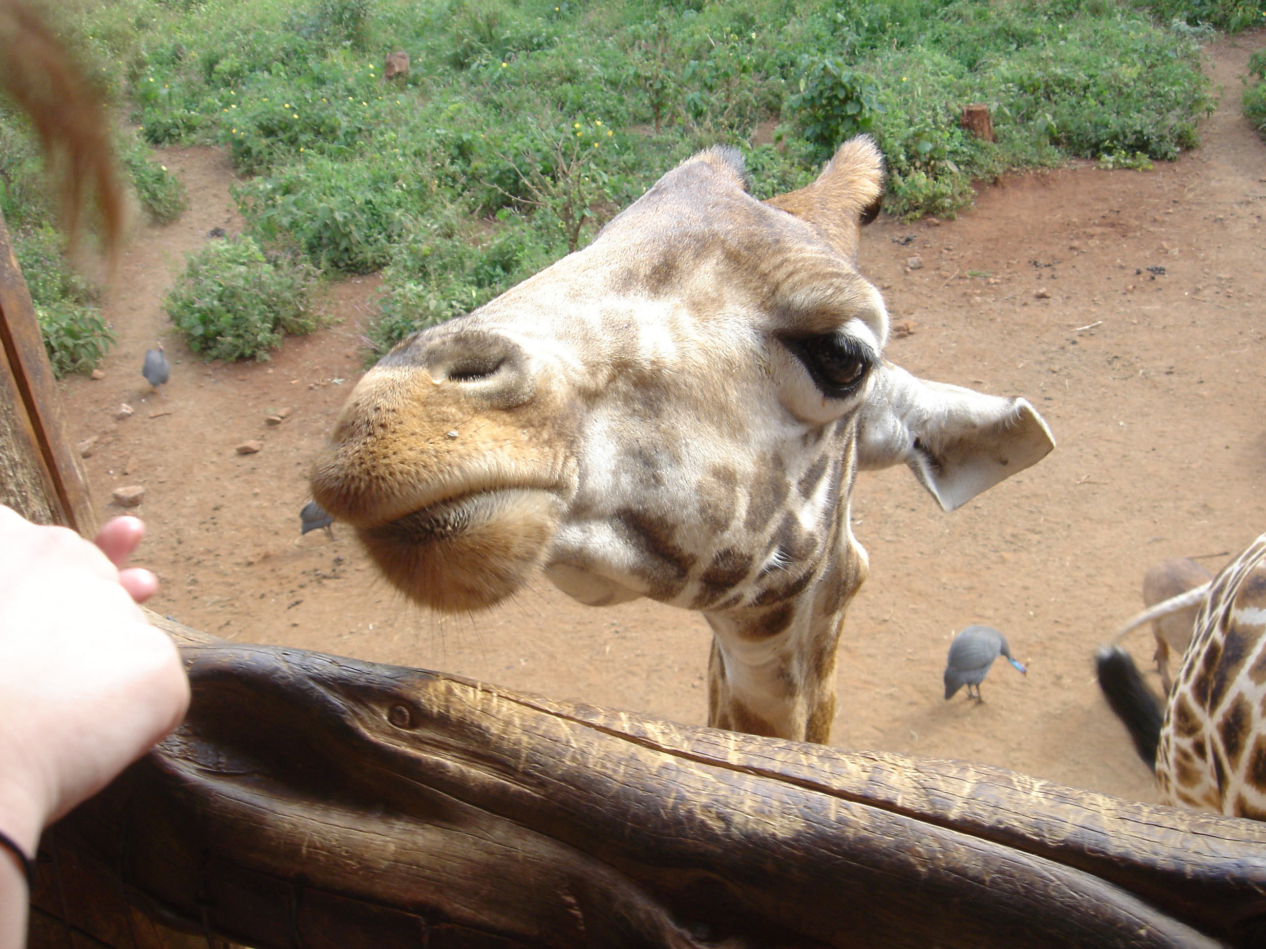

THE PROGRAM

Kenya Summer Study Abroad Program focuses on environment, culture and development. Visits to cultural and historical sites will include colonial settlements in Kimuru, Karen Blixen Museum, Bomas of Kenya, Railway Museum, Village Market, Nairobi National Museum, Orogessaile Archaeological Site in the Rift Valley, Fort Jesus, Gede Ruins Archaeological Site, Ngomongo Villages and many more. Visits to plant and wildlife rich areas will include overnight stays in Mount Kenya (the second largest mountain in Africa), Lake Nakuru National Park (home of the flamingoes), the world renowned Maasai Mara that adjoins the Serengeti of Tanzania, and Amboseli National Park.

Lectures are provided by an invited guest speaker University of Nairobi faculty, a WPU faculty, local specialists on the ecology and history of selected communities. Additionally, Kenyan guides trained in history and ecology of particular sites will be invited to share their knowledge and experiences with the students.

Following one week of intensive classroom instruction, there is a two week field study/safari. The field study is a follow up of classroom instruction which will give students an opportunity to witness first hand what they have learned in the classroom. In various hotels where we will stay overnight, there are special programs including slide shows of local ecology, entertainment by African dancers, talks about the history and culture of local groups and many more. These programs usually follow dinner and are very educational.

COURSES

GEO 334 Geography of Africa/GEO 399 African Economic History, GEO 220 Environment and Humans. These are 3 credit courses. Students can register for either 3 or 6 credits.

QUESTIONS

If you have any questions regarding the program, contact:

Dr. Monica Nyamwange at 9730-720-2438 or by email at nyamwangem@wpunj.edu

