The Gandhian Forum for Peace & Justice

William Paterson University

presents

Rashid Khalidi

Edward Said Professor of Arab Studies

at Columbia University

speaking on

Prospects for Peace in Palestine
Wednesday, March 2, 2011, 2:00-3:15 p.m.
University Commons, Ballroom C
William Paterson University
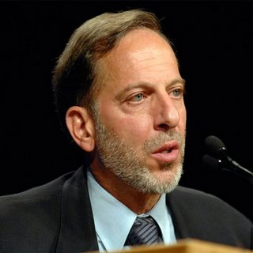
For more than six decades, conflict has raged between Palestinians and Israelis. War, displacement, terrorism, and occupation have seemed endless, with the occasional peace effort always failing. Is there a road to peace in Palestine? Can a just solution be achieved? What is required of the two parties and what role is there for the United States?
No one is better qualified to address these issues than Rashid Khalidi. Professor Khalidi received his BA from Yale in 1970, and his D.Phil. from Oxford in 1974. He is editor of the Journal of Palestine Studies, and was President of the Middle East Studies Association and an advisor to the Palestinian delegation to the Madrid and Washington Arab-Israeli peace negotiations from October 1991 until June 1993. He is author of, among other works, Sowing Crisis: American Hegemony and the Cold War in the Middle East (2009), The Iron Cage: The Story of the Palestinian Struggle for Statehood (2006), Resurrecting Empire: Western Footprints and America’s Perilous Path in the Middle East (2004), Palestinian Identity: The Construction of Modern National Consciousness (1997), The Origins of Arab Nationalism (co-editor, 1991), Under Siege: P.L.O. Decision-making during the 1982 War (1985), and British Policy towards Syria and Palestine 1906-1914: The Antecedents of the Hussein-McMahon Correspondence, the Sykes-Picot Agreements and the Balfour Declaration (1980).
All Are Welcome
For more information, please contact Prof. Steve Shalom, 973-720-3433, or shaloms@wpunj.edu.
Co-sponsored by the Depts. of Anthropology, History, Languages & Cultures, and Political Science, the Master's Program in Public Policy & International Affairs, the Asian Studies Program, the College of Education, the College of Humanities & Social Sciences, the Cotsakos College of Business, the Office of the Provost, and PalestinianGandhis.org

