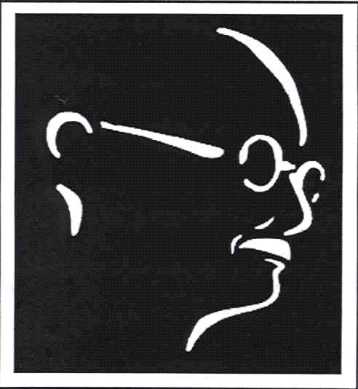
The Gandhian Forum for Peace & Justice

William Paterson University

presents

Jo Comerford

speaking on

New Jersey Out of Balance:
The Impact of Federal Spending
In an Economic Crisis

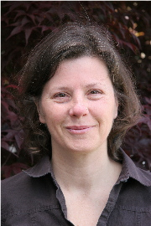
When: Tuesday, October 5,
12:30-2:00 p.m.
Where: University Commons Ballroom C
William Paterson University, Wayne, NJ

We face terrible economic times -- in New Jersey and across the nation. Jobs lost, homes foreclosed, services slashed, tuition sky-rocketing. How do our national priorities affect our local situation? What is the impact of war and military spending on our state economy? What sort of federal budget do we need to address the problems of economic distress, environmental challenge, and global peace and justice? Jo Comerford will address these issues in a talk open to the university community and to the public.
Comerford is the Executive Director of the National Priorities Project, an organization that since 1983 has been analyzing and clarifying federal data so that people can understand and influence how their tax dollars are spent.

Co-sponsored by the Political Science Dept. and the Office of the Provost
For more information, contact Prof. Steve Shalom, 973-720-3433, shaloms@wpunj.edu.

