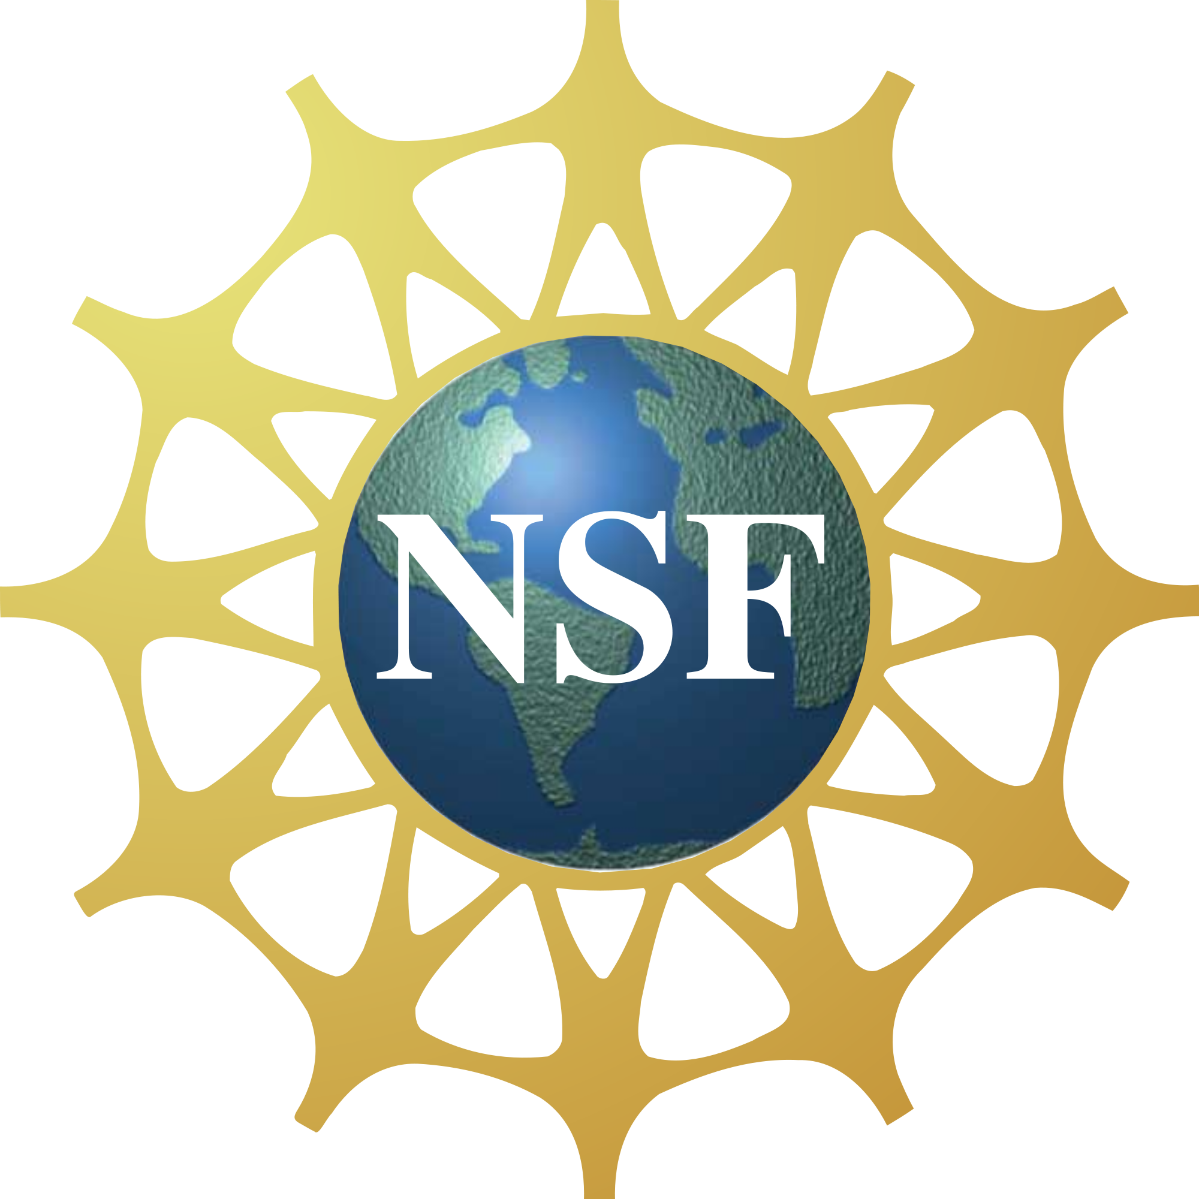
ROBERT NOYCE

SUPPLEMENTAL INSTRUCTION Program
FUNDED BY THE NATIONAL SCIENCE FOUNDATION
  - Undergraduates studying science or math who might want to pursue a career in teaching can apply for the Noyce Supplemental Instruction (SI) program. The SI leaders will be working with the Academic Success Center at William Paterson University. Please see http://www.wpunj.edu/academics/asc/si.html for more information.
  - INSTRUCTIONS
  - Eligibility:
- U.S. citizen, national, or permanent resident alien at the time of application.
- Mathematics / Science major at William Paterson University.
- Completion of at least 30 credits.
- Overall Grade Point Average (GPA) of 3.0 at WPUNJ. Transfer students should have a 3.0 from their transfer institution.
- Have an interest in teaching, but don’t need to be pursuing an education degree
- Be enthusiastic and interested in teaching students.

  - Requirements:
- You must participate in NOYCE related surveys and interviews throughout your SI program and while you are at WPU.

  - Application Process:
You are required to electronically submit the following to hilld@wpunj.edu or champanerkarj@wpunj.edu :
- Completed application form (Page 2).
- Documentation of citizenship status (photocopy or scan of passport, birth certificate, permanent resident card, etc.)
- ONE letter of recommendation addressed to the Robert Noyce Advisory Board at WPU.
- A short personal statement (no more than 1 typed page) outlining your reasons for interest in this program as well as your career goals.

Only applications accompanied by all supporting documents will be given full consideration.
For questions / application submission, email: Dr. Djanna Hill or Dr. Jyoti Champanerkar

ROBERT NOYCE

SUPPLEMENTAL INSTRUCTION Program
FUNDED BY THE NATIONAL SCIENCE FOUNDATION

  - SI leader Application Form

Name: ID Number: 855

Date of Birth: Current Status: Full time / Part time (Circle one.)

Street Address: Town:
State: Zip:

Home Phone Number: Cell Phone Number:

Email: Alternate Email:

STEM Major: Biology / Chemistry / Computer Science / Environmental Science /
Integrated math & Science / Mathematics (Circle one.)

Education Major: P-3 and K-6 / K-6 / K-6 with 5-8/ K-6 with TSD / K-12 / K-12 with TSD

Overall GPA: Anticipated Date of Graduation from WPUNJ: _______________

Awards/ Recognition (Include dates for Scholarships, Dean's List, etc.):

Community Activities (include dates):
Extracurricular Activities (Include dates, name of organization / team, position held):

Work Experience:

Additional Pertinent Information:

Please use additional sheets if needed.
For questions / application submission, email: Dr. Djanna Hill or Dr. Jyoti Champanerkar

