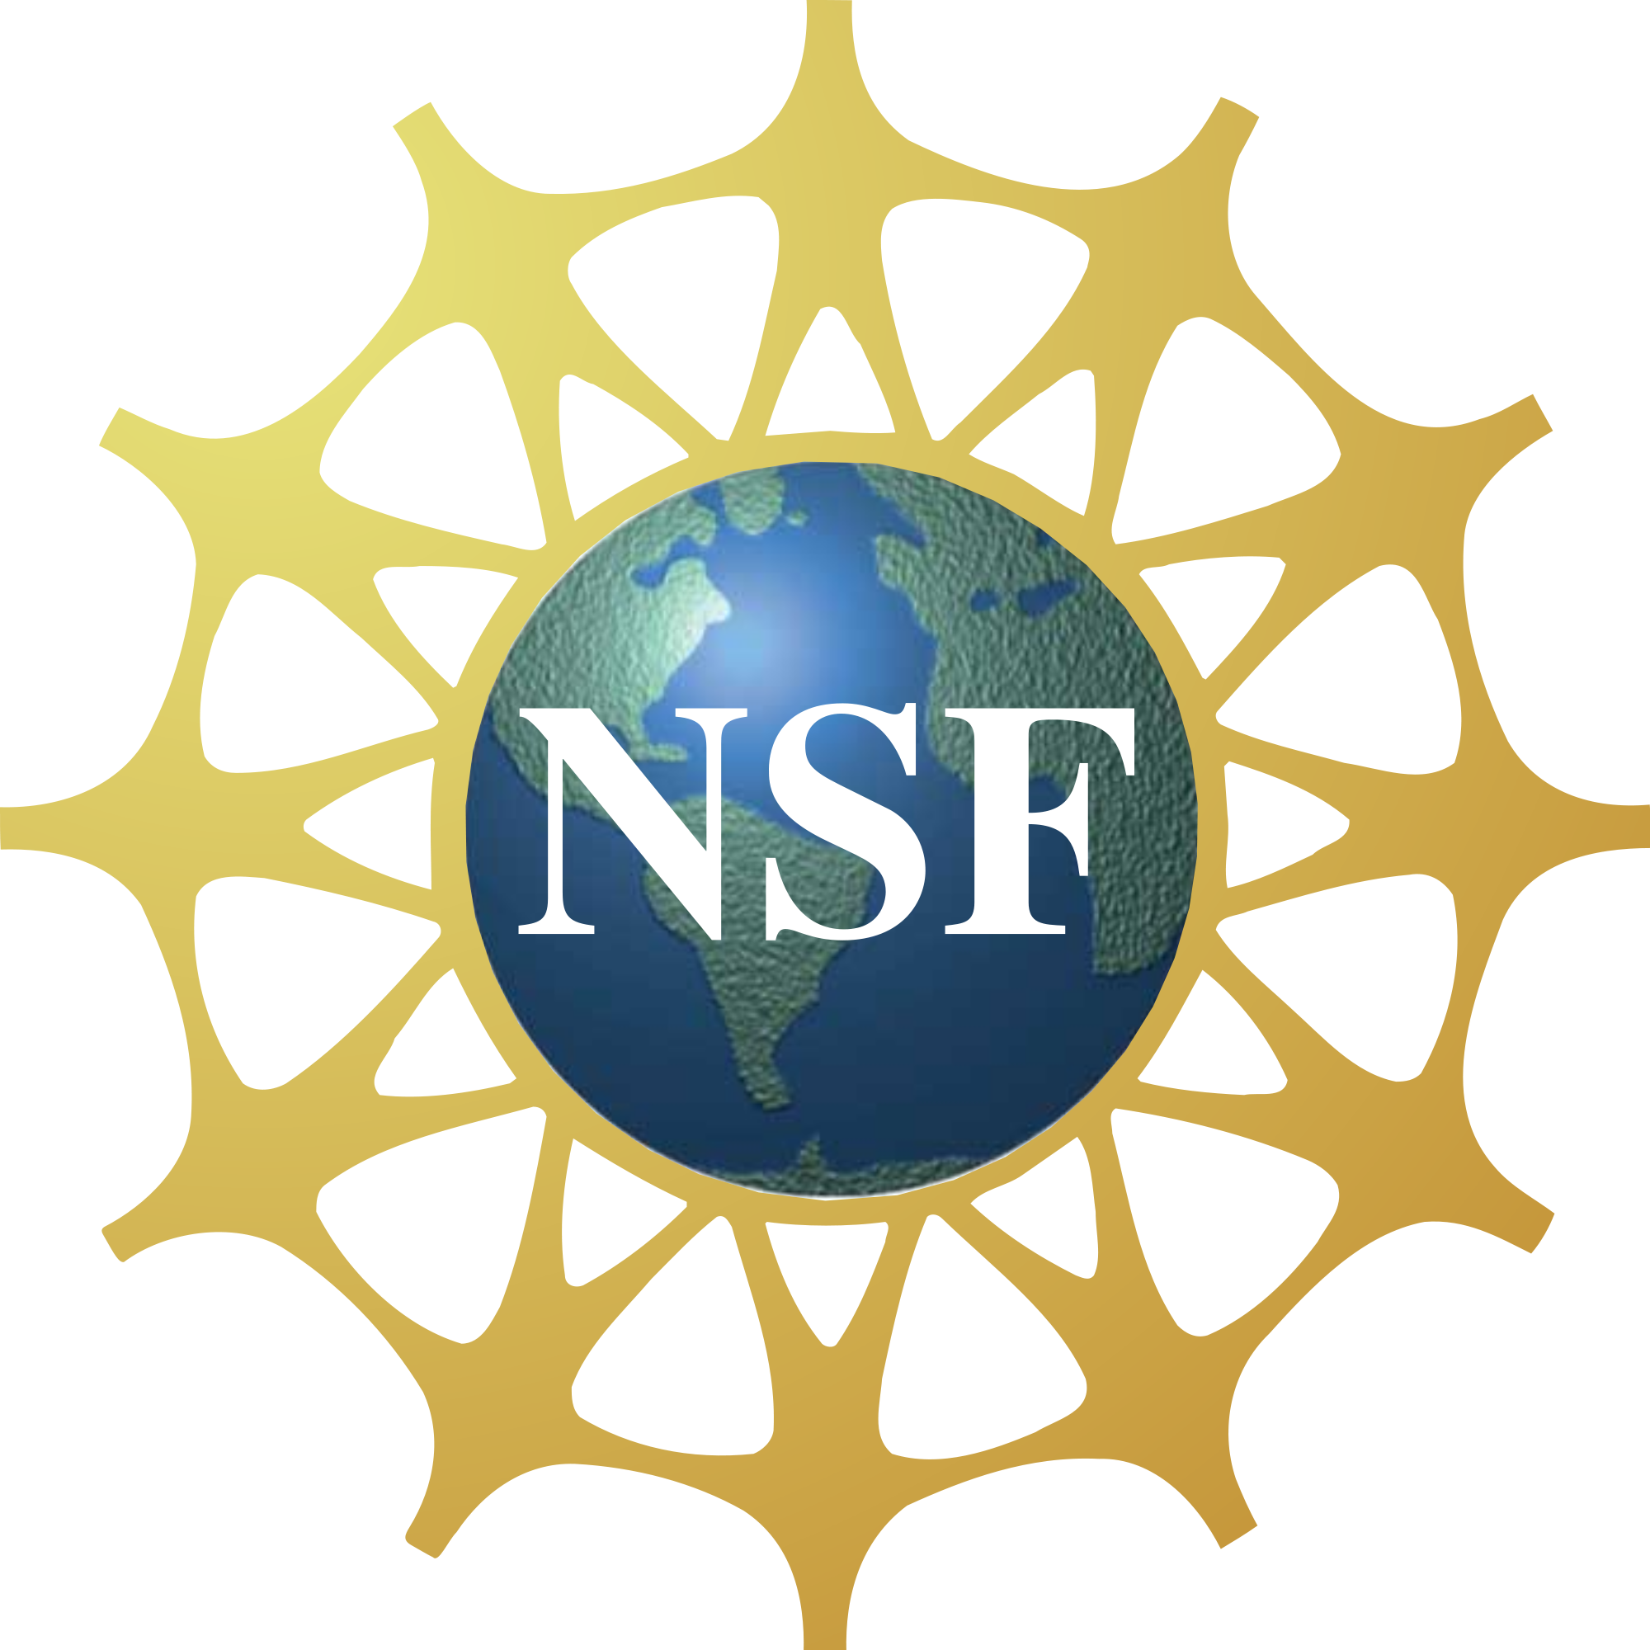
ROBERT NOYCE

SUMMER TEACHING INTERNSHIP
FUNDED BY THE NATIONAL SCIENCE FOUNDATION
  - Undergraduates studying science or math who might want to pursue a career in teaching can apply for summer internships at WPUNJ. The interns will be working with the “Summer Youth Programs” at William Paterson University. These are mainly pre-college programs for high school students, and some for middle school students. They take place during the summer at WPUNJ. Selected interns will help to prepare and run the academic workshops for two weeks between mid-July mid-August (exact dates to be determined). Interns will be paid $450/week for 2 weeks.
  - INSTRUCTIONS
  - Eligibility:
- U.S. citizen, national, or permanent resident alien at the time of application.
- Mathematics / Science major at William Paterson University.
- Completion of at least 30 credits.
- Overall Grade Point Average (GPA) of 3.0 at WPUNJ. Transfer students should have a 3.0 from their transfer institution.
- Have an interest in teaching, but don’t need to be pursuing an education degree
- Be enthusiastic, willing to attend events, and work at the program (exact dates to be determined).

  - Requirements:
- You must participate in NOYCE related surveys and interviews throughout your internship and while you are at WPU.

  - Application Process:
You are required to electronically submit the following to hilld@wpunj.edu or champanerkarj@wpunj.edu :
- Completed scholarship application form (Page 2).
- Documentation of citizenship status (photocopy or scan of passport, birth certificate, permanent resident card, etc.)
- ONE letter of recommendation from a faculty member who taught you science or math addressed to the Robert Noyce Advisory Board at WPU.
- A short personal statement (no more than 1 typed page) outlining your reasons for interest in this internship as well as your career goals.

Only applications accompanied by all supporting documents will be given full consideration.
For questions / application submission, email: Dr. Djanna Hill or Dr. Jyoti Champanerkar

ROBERT NOYCE

SUMMER TEACHING INTERNSHIP
FUNDED BY THE NATIONAL SCIENCE FOUNDATION

  - Internship Application Form

Name: ID Number: 855

Date of Birth: Current Status: Full time / Part time (Circle one.)

Street Address: Town:
State: Zip:

Home Phone Number: Cell Phone Number:

Email: Alternate Email:

STEM Major: Biology / Chemistry / Computer Science / Environmental Science /
Integrated math & Science / Mathematics (Circle one.)

Education Major: P-3 and K-6 / K-6 / K-6 with 5-8/ K-6 with TSD / K-12 / K-12 with TSD

Overall GPA: Anticipated Date of Graduation from WPUNJ: _______________

Awards/ Recognition (Include dates for Scholarships, Dean's List, etc.):

Community Activities (include dates):
Extracurricular Activities (Include dates, name of organization / team, position held):

Work Experience:

Additional Pertinent Information:

Please use additional sheets if needed.
For questions / application submission, email: Dr. Djanna Hill or Dr. Jyoti Champanerkar

