

2014 Edition

Technical Services Window

Brochure

Table of Contents

About Us 3

Competency Test Policies 4

Equipment/Room Reservation Policies 6

Additional Reservation Policies 8

Cameras 8

Tripods 9

Lighting Kits 11

Film and TV Microphones 14

Audio Production Microphones 17

Audio Accessories 19

Other Equipment 22

Manuals and DVDs 24

Steadicam 28

Contact Information 29

**About Us**

The Technical Services Window (TSW) at Hobart Hall is located in room 116. The TSW is a place where students and faculty can come and reserve video and audio equipment.

The equipment the TSW has to offer includes, but is not limited to, Sony PMW-200, Canon 7D, and FS700 Cameras, Sachtler and Bogen tripods, a wide variety of lights, Microphones, and laptops.

The TSW also offers access to audio and video editing labs. Our editing labs all are **fully functional** and come with a wide array of video and audio editing software that includes, Avid Media Composer, Adobe Premiere, Final Cut Pro X, ProTools, iMovie, and more.

These resources are available to all registered students of William Paterson University who are **currently enrolled** in the Communication Classes that **require** them to take out this equipment, some of these classes include:

* Film Making I, II, and III
* Video Production & Editing
* Advanced TV Production
* Visual Effects
* Audio and Radio Production
* Advanced Audio Production
* Radio News
* Radio Workshop
* Advanced Broadcast Journalism
* Electronic News Gathering
* Capstone

The TSW is open Monday through Friday, 8:00 AM – 10:00 PM, and 9:00 AM- 5:00 PM on Saturdays.

As stated before, the TSW allows students and Faculty to reserve and take out equipment for classes and projects. In most cases the students will learn how the equipment is used in their classes, but in this brochure we will go over a few examples on how the equipment is used and how you can use the equipment to enhance your projects.

**Competency Test Policies**

In order for a student to be eligible to take a competency test, a student **must** be in a Communication Department class that requires them to use the equipment and/or editing facilities. Faculty members **must** email their rosters to Rob Meyer ([meyerr@wpunj.edu](mailto:meyerr@wpunj.edu)) and the Technical Services Window ([tsw@wpunj.edu](mailto:tsw@wpunj.edu)) so their students can be added to our “List of Names.” You must be on this list before you can even take a Competency Test.

**Everyone** who takes out equipment must complete a "TSW Agreement Form".  This includes both Media Production **and** Audio students.

If someone has not completed a form they must complete it before they are permitted to take out any equipment.  This form provides TSW Staff with contact information in the event there is a problem with a student’s booking or if parts are missing from returned equipment. This also serves as a reference that the students have agreed to the terms and conditions of renting the equipment that the TSW provides.

---

**Everyone** who takes Media Production equipment must pass the competency test for that equipment before they can take it out. Some students, who are not in a class that teaches an editing program, will be required to take a competency test for the software they wish to use. The courses that do not teach an editing software include Capstone, Film 3, Visual Effects, Electronic News Gathering, and Advanced Broadcast Journalism.

While tests are often administered immediately to students who ask for it, please note that students may sometimes have to schedule an appointment.  There are tests for the following equipment:

* PMW 200
* Canon 7D
* FS 700
* Sachtler Tripod
* Bogen Tripod
* Omni, Pro, Tota, and V-Lights
* Rifa Light
* Final Cut Pro X
* Adobe Premiere
* Avid Media Composer
* Protools

Students who fail the equipment competency test will **not** be permitted to borrow the desired equipment until he or she retakes and passes the test. If a student fails a competency test, he/she must wait 24 hours before taking retaking the test.  There is no limit on how many times the test can be taken.  If a student would like to prepare, there video tutorials available on the web, as well as equipment manuals available online.

---

Capstone students **must** take the Final Cut Pro/Premiere/Avid Competency Test before they can begin editing their projects.  Capstone students who fail to do so will **not** be given a log in and will **not** be able to edit their projects.

**Equipment/Room Reservation Policies**

The maximum time that anyone can reserve equipment is for 24 hours on weekdays (Monday-Friday).  Students can reserve equipment for a weekend booking. Starting at 12pm on Friday, students can borrow the equipment until 10 AM on Monday. Any longer periods must be approved by a professor.

---

Unless he or she is given permission by their professor, students may only have one weekend booking and one weekday booking at a time.  This means a student cannot reserve equipment for two separate weekends at the same time and must wait until their current weekend booking is completed before he or she will be able to reserve equipment for the next weekend.  Professors must email TSW Staff ([tsw@wpunj.edu](mailto:tsw@wpunj.edu)) permission for a student in advance.

---

In order to **reserve** equipment or edit time students must be in a class that requires them to use the equipment.  To determine this, professors **must** email Rob Meyer ([meyerr@wpunj.edu](mailto:meyerr@wpunj.edu)) or TSW Staff ([tsw@wpunj.edu](mailto:tsw@wpunj.edu)) an up-to-date class list so that all of their students can be accounted for.  If they are not on the list, they cannot take out equipment and need written permission from a **Full Time** Audio, TV, or Media Production Professor to be added to the list as a “Non-Class User”.  Professors should email both Rob Meyer and the TSW Staff ([tsw@wpunj.edu](mailto:tsw@wpunj.edu)) with permission.

“Non-Class Users” can borrow, but **cannot reserve**, equipment. Instead, Non-Class Users may come to the window and see if equipment is available at the time they wish to take it out.  In addition, Non-Class Users **cannot** reserve editing time in advance, but they **can** come to the TSW to see if there is time available at that moment to edit.

---

If a student does not show up within **30 minutes** of their booking for either equipment or edit time, TSW Staff reserves the right to give away that equipment or time to someone else.  Please call TSW Staff in advance at **973-720-2026** if you know you are going to be more than 30 minutes late.

---

Students should double-check their equipment before leaving the Technical Service Window to be sure you have everything.  **Immediately** inform TSW Staff if you have received an incomplete kit or if equipment is missing from the editing rooms.

---

Students can only take out **1 camera** at a time unless they get special permission from their professor.  Professors must email TSW Staff ([tsw@wpunj.edu](mailto:tsw@wpunj.edu)) permission for a student in advance.

---

Students will be charged **$1 per hour for each piece of equipment that is returned late**.  Fines accrue immediately after the Due Date is passed.  (Ex. If due at 8:00 PM, $1 will be charged immediately at 8:00 PM). In a camera bag, there is an average of nine items, so if it’s one hour late, that’s $9.00 in fines. This is non-negotiable. All fines must be paid at Lending Services in the Library. If a student has $10 or moe worth in fines, they cannot take equipment out. Their account is blocked in our system, and only when their fines are below $10 will they be able to take equipment from the TSW.

---

The days before Holiday weekends, such as President’s Day, are treated like Fridays.  Students are allowed to take out equipment the day before the holiday weekend after 12 PM and may return it the next Monday at 10 AM.

**Additional Reservation Policies**

When a student is reserving time in the editing labs, he or she is only allowed a **maximum 4 hours per day**.  This reservation does not have to be a solid 4-hour block, instead they may book time on separate occasions within a day but the max it can add up to is 4 hours.  (ex. A patron can book time from 2 PM – 6 PM, they are also allowed to book time from 10 AM – 12 PM and 2 PM – 4 PM, and this equals a total of 4 hours.)

The **maximum amount of time a student can reserve within a week is 8 hours**.  If more time is needed by the student for their projects, they may make another booking after their original booking is finished, and this is only under the circumstance that there is time available in the labs.  There is no limit to these “first come first serve” reservations as long as there is time available for the patron to book.

---

If a student is found with food and/or beverage in any of the Audio labs or Video Editing suites, they will receive a warning.  If, upon returning, TSW Staff members find that the student has not disposed of the food or beverage, they will lose the rest of their edit time and be asked to leave.

---

If you have any questions about our policies, you may contact the TSW at x2026 and [tsw@wpunj.edu](mailto:tsw@wpunj.edu), or contact Rob Meyer at x2613 and [meyerr@wpunj.edu](mailto:meyerr@wpunj.edu).

**Cameras**

|  |  |
| --- | --- |
|  |  |
| Sony-PMW-200-camcorder.jpg | Sony PMW-200 Kit Includes: Camera, 2 Batteries, Battery Charger and cable, Wireless Receiver, Wireless Transmitter, White Balance Card, Slate, Lavalier Microphone, Wireless Mic Accessories, and Detachable Shotgun Microphone.  Available: 17 kits |
| canon-7d-firmware-upgrade.jpg | Canon 7D Kit Includes: Camera Body, 18-200mm Lens, 2 Batteries, Battery Charger, Wireless Receiver, Wireless Transmitter, White Balance Card, Lavalier Microphone, Zoom H4n, H4n Accessories, Wireless Mic Accessories, and Slate.  Available: 9 kits |
| Sony_NEX-FS700_Display.jpg | Sony FS-700 Kit Includes: Camera, 2 Batteries, Battery Charger and cable, Wireless Body Pack, Wireless Receiver, Wireless Transmitter, White Balance Card, Slate, Wireless Mic Accessories, and Detachable Shotgun Microphone.  Available: 4 kits |

**Tripods**

|  |  |
| --- | --- |
|  | Sachtler DV2 Tripod Features: Camera Plate, Pan Lock/Friction, Tilt Lock/Friction, Balance Bar, and Extendable Legs.  Tripods: 1, 2, 3, 4, 5, 6, 7, 8, and 9 |
|  | Sachtler FSB2 Tripod Features: Camera Plate, Pan Lock/Friction, Tilt Lock/Friction, Balance Bar, and Extendable Legs.  Tripods: 16 and 17 |
| http://www.richardwalch.com/richardwalchcom/wp-content/uploads/2013/01/sachtler_dslr_T8B8131-1660x1107.jpg | Sachtler FSB6 Tripod Features: Camera Plate, Pan Lock/Friction, Tilt Lock/Friction, Balance Bar and Extendable Legs.  Tripods: 10, 11, 12, 13, 14, 15, and 21 |
|  | Bogen Manfrotto 503 Tripod Features: Camera Plate, Pan Lock/Friction, Tilt Lock/Friction, and Extendable Legs.  Tripods: 22 and 23 |

|  |  |
| --- | --- |
| untitled | Sachtler Video 14II Tripod Features: Camera Plate, Pan Lock/Friction, Tilt Lock/Friction, Balance Bar, and Extendable Legs.  Tripod: 20 |

**Lighting Kits**

|  |  |
| --- | --- |
| http://www.leoscamera.com/Video/lowel/TO983Z.jpg | Omni/Tota Lighting Kit Includes: 2 Omni lights, 1 Tota light, 2 Gel frames, 1 Scrim, 3 Power Cords, 1 Lampak with extra light bulbs, 3 Stands, and 1 Umbrella.  Kit: 1, 2, and 14 |
| http://www.lowel.com/images/kits/TOR95Z.jpg | Rifa (Black) Lighting Kit Includes: 1 Omni light, 1 V-Light, 1 Rifa light with storage bag, 1 “Egg Crate” with storage bag, 1 “White Screen” light diffuser, 2 Power Cords, 3 Stands, 1 Umbrella, 1 Gel frame, and 1 Lampak with extra bulbs.  Kits: 3 and 4 |
| No  Photo  Available | Four Piece Lighting Kit Includes: 2 Omni lights, 1 Pro light,1 V-Light, 3 Power Cords, 4 Stands, 1 Scrim, 1 Umbrella, 1 Gel frame and 1 Lampak with extra bulbs.  Kit: 5 |
| http://www.leoscamera.com/Video/lowel/TO983Z.jpg | Omni/Pro Lighting Kit Includes: 2 Omni lights, 1 Pro light, 3 Power Cords, 3 Stands, 1 Scrim, 1 Umbrella, 2 Large Gel frames, 1 Small Gel frame and 1 Lampak with extra bulbs.  Kit: 6 |

|  |  |
| --- | --- |
|  |  |
| http://www.leoscamera.com/Video/lowel/VP98UZ.jpg | Pro/V-Light Lighting Kit Includes: 2 Pro lights, 1 V-light, 3 Stands, 2 Power cords, 2 Gel frames, 3 Light mount pieces for V-light, 1 Lampak with extra light bulbs, and 1 Umbrella.  Kits: 9, 10, 11, 12, and 13 |
| http://www.leoscamera.com/Video/lowel/TO983Z.jpg | Omni/Tota Lighting Kit Includes: 2 Omni lights, 1 Tota light, 2 Gel frames, 1 Scrim, 3 Power Cords, 1 Lampak with extra light bulbs, and 1 Umbrella.  Kit: 14 |
| untitled | Omni Lighting Kit Includes: 3 Omni lights, 3 Gel frames, 3 Scrims, 3 Power Cords, and 1 Lampak with extra light bulbs.  Kits: 12,13, 14, 15, 16, 17, 18,19, 20, and 21 |

**Lighting Gel Kits**

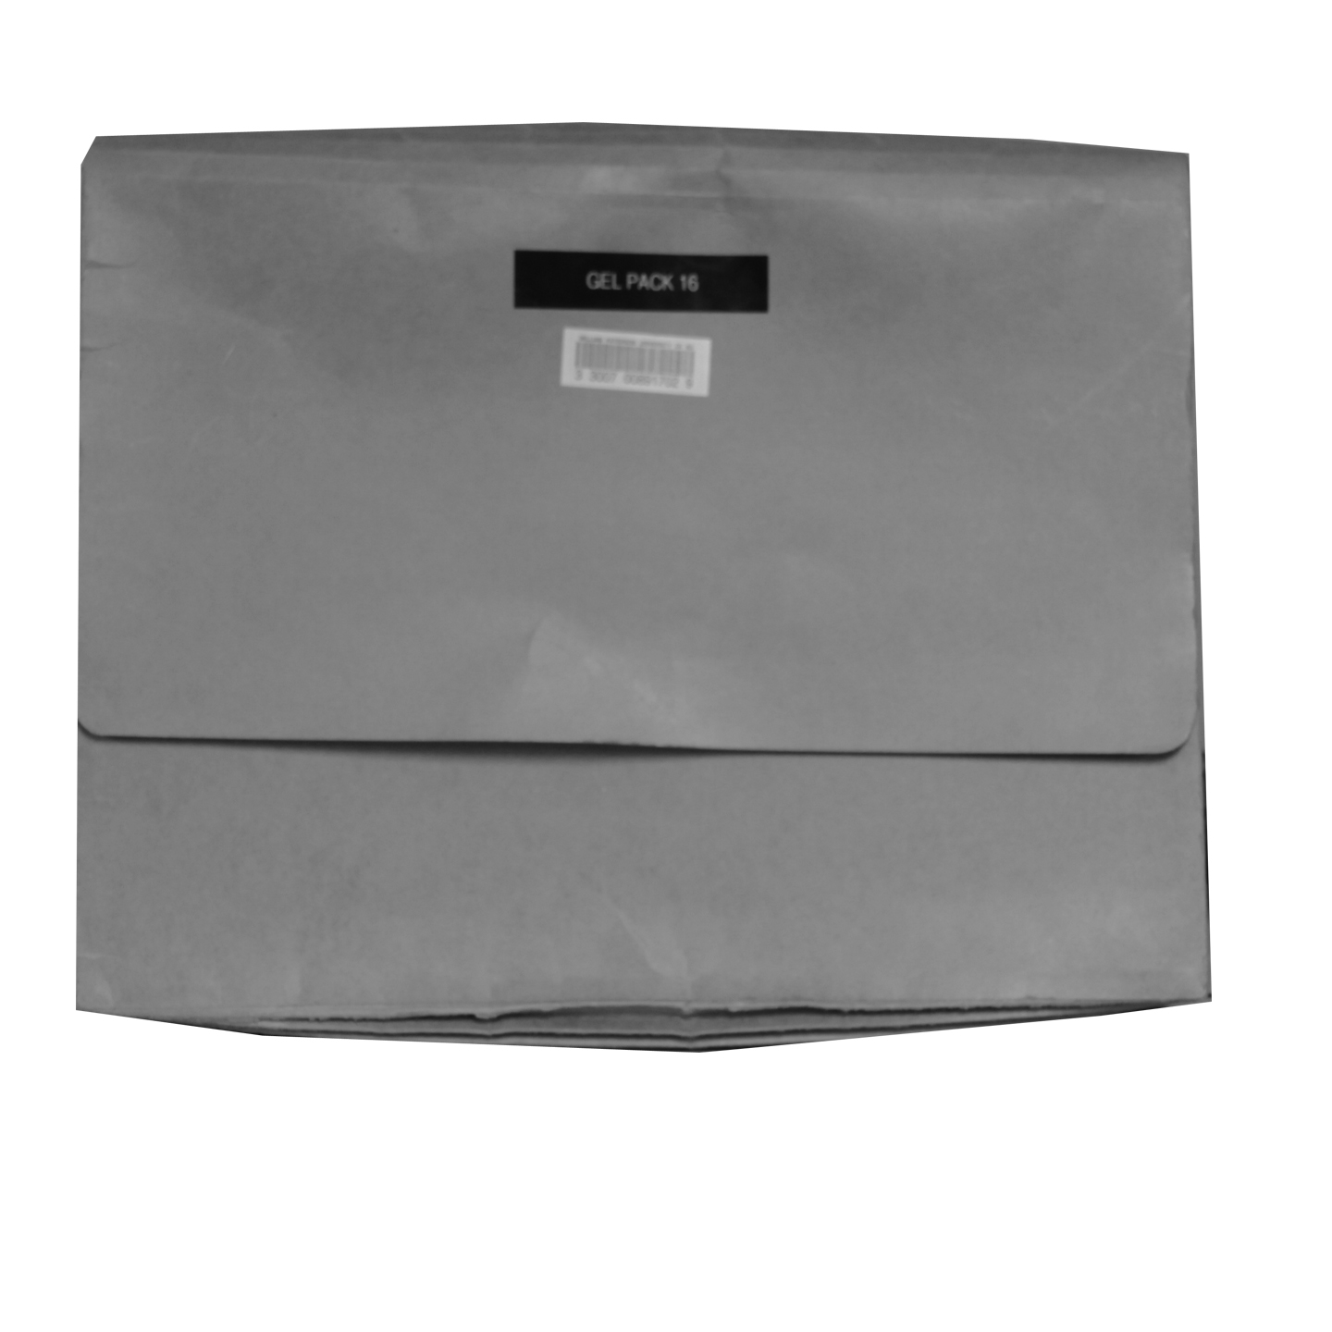 Available: 16 kits

|  |  |
| --- | --- |
| http://www.adorama.com/images/product/PFLD52WS.jpg | **Photoflex 42-Inch-Wide Reflectors**  Available: 6, in protective cases. |

Film and TV Microphones

|  |  |
| --- | --- |
| http://www.studio1productions.com/images/boommic.jpg | Shotgun Microphone and Boom Pole Includes: 1 Shotgun Microphone and 1 Boom Pole.  Available: 13 booms |
| http://www.madmanaudio.com/images/MADMANAUDIO%20-%20%20ev%20micc.jpg | Handheld Microphone Kit Includes: 1 Electro-Voice 635A Dynamic Omnidirectional Microphone and 1 XLR cable.  Kits: 1, 2, 3, 4, 5, 6, 7, 8, 9, 10, 11, and 12. |
| http://www.djequipmentstore.com/media/catalog/product/cache/1/small_image/170x170/5e06319eda06f020e43594a9c230972d/6/3/635ndb.jpg | 635L-B Dynamic Omnidirectional Microphone Kits: 13, 14, and 15 |
| http://www.madmanaudio.com/images/MADMANAUDIO%20-%20%20ev%20micc.jpg | 635A Dynamic Omnidirectional Microphone Kits: 16 and 17 |

|  |  |
| --- | --- |
| http://www.studiocare.com/store/images/products/Electrovoice/SELERE50.jpg | RE50 Dynamic Omnidirectional Microphone Kit: 18 |
| RE10mic | RE10 Dynamic Cardiod Microphone Kit: 19 |
| http://www.studiocare.com/store/images/products/Electrovoice/SELERE50.jpg | RE50B Dynamic Omnidirectional Microphone Kit Includes: 1 RE50B Dynamic Omnidirectional Microphone, 1 XLR cable *or* 1 Microphone Clip.  Kits: 20, 21, 22, 23, 24, 25, and 26 |
|  |  |

|  |  |
| --- | --- |
| http://www.talamas.com/Merchant2/images/R_UCR100UH100LARGE.jpg | Wireless Microphone Kit Includes: 1 Wireless Receiver, 1 Wireless Broadcaster, a Wireless Receiver Holder, and an XLR to 1/8 in. plug converter.  Kits: 1 and 2 |
| http://ecx.images-amazon.com/images/I/21b2kXl4ECL.jpg | RadioShack Unidirectional Dynamic Microphone Available: 2 microphones |
| Optimus | Optimus Dynamic Microphone Available: 2 microphones |
| http://www.westbuy.ro/en/poze/322_322_logo%20%20sony%20ecm44b.jpg | Lavalier Microphone Kit Includes: 1 Lavalier microphone, 1 spare AA battery, and 1 Microphone clip.  Available: 8 |

Audio Production Microphones

|  |  |
| --- | --- |
| http://www.e-xigo.com/images/374504901479e25182b272_resize.jpg | Stereo PZM Ambient Microphone Kit Includes: 1 Microphone, 1 Handle, and a Cover.  Advanced Microphone Kit: 1  FOR USE BY ADVANCED AUDIO PRODUCTION STUDENTS ONLY |
| http://www.americanmusical.com/ProductImages/Large/p13734.jpg | Large Dual Diaphragm Microphone Kit Includes: 1 KSM44 Microphone with sleeve, 1 Microphone cradle, and 1 Microphone Holder Bracket.  Advanced Microphone Kit: 2 and 3  FOR USE BY ADVANCED AUDIO PRODUCTION STUDENTS ONLY |
| http://www.dv247.com/assets/products/28880_l.jpg | VP88 Stereo Condenser Microphone Advanced Microphone Kit: 4  FOR USE BY ADVANCED AUDIO PRODUCTION STUDENTS ONLY |

|  |  |
| --- | --- |
| http://mcleansound.com/sm57.jpg | SM57 Dynamic Microphone Advanced Microphone Kits: 5 and 6  FOR USE BY ADVANCED AUDIO PRODUCTION STUDENTS ONLY |
| http://www.video54.nl/wp-content/uploads/79b73e2b9220155763a828a9b75b98c1.jpg | Perception 220 Large Condenser Microphone Kit Includes: 1 Perception 220 large condenser microphone and 1 Microphone cradle.  Advanced Microphone Kit: 7  FOR USE BY ADVANCED AUDIO PRODUCTION STUDENTS ONLY |

**Audio Accessories**

|  |  |
| --- | --- |
| http://www.parts-express.com/images/item_standard/242-500_s.jpg | **Audio-Technica ATH-M20 Headset**  2 Headsets |
| http://reviews.cnet.com/sc/6898610-2-200-0.gif | **Audio-Technica ATH-908 Headset**  1 Headset |
| http://i.testfreaks.com/images/products/600x400/205/akg-k44.3874509.jpg | **AKG K-44 Headset**  8 Headsets  FOR USE BY ADVANCED AUDIO PRODUCTION STUDENTS ONLY |
| http://www.red5audio.com/acatalog/XLR.jpg | **XLR Cable (Male to Female)**  Available: 15 cables in various sizes |
|  |  |
| http://www.samsontech.com/images/productimages/H1_side-hero-web.jpg | **Zoom Recorder Kit**  Includes: 1 H1 Handy Recorder, 1 Tripod, 1 Handle, 1 Windscreen, 1 USB Power Adapter, 1 USB Cable, and Instruction Booklet.  Available: 10 kits |
| h4n.jpg | **H4N Recorder Kit**  Includes: 1 H1 Handy Recorder, 1 Tripod, 1 Handle, 1 Windscreen, 1 USB Power Adapter, 1 USB Cable, and Instruction Booklet.  Available: 4 kits |
| http://www.filmsensei.com/images/beachtek-dxa4-adapter.jpg | **DXA XLR Adapter**  Available: 3 adapters |

|  |  |
| --- | --- |
| http://www.quickav.com/catalog/pimage_99788.jpg | **Fixed Microphone Stands**  Available: 4 stands in various sizes and with clips |
| http://www.idjnow.com/ProductImagesLarge/MS7701B.jpg | **7701B Mic Stand with Boom Arm**  Available: 4 stands with clips |

**Other Equipment**

|  |  |
| --- | --- |
| http://www.kerisys.com/migrated-media/images/products/fullsize/MT-26_Card.jpg | **Audio Lab Key Cards**  Required to use Audio Labs A, B, C, and 224. |
| http://www.itechnews.net/wp-content/uploads/2007/05/Dell-Latitude-D630-Santa-Rosa-Laptop.jpg | **Dell Latitude D630 Laptops**  Available: 24 laptops |
| http://laptopsparesonline.com/uploads1/products/img3/184661_1154037135.jpg | **Laptop Power Cables**  Available: 3 cables |
| http://www.hbc.com.pk/images/AccessoriesWebCamLogitechQuickCam%20Messenger.gifhttp://www.headsetsolutions.com.au/images/audio750dsp.jpg | **Webcam Kit**  Includes: 1 Webcam, 1 Headset and Installation Manual  Available: 1 kits |

**Steadicam**

|  |  |
| --- | --- |
| http://www.dvestore.com/product_images/q/609/steadicampilot__24192_zoom.jpg | **Steadicam Pilot Kit**  Includes: Remote, BNC Adapter, Camera Fasteners, Power Adapter, RCA Cable, Allen Wrench, Forearm, Pin, Sled, Sled Mounting Pin, Upper Arm, Docking Bracket, 4 Small Weights, 4 Big Weights, Dry Erase Marker, Steadicam Vest, 2 Upper Arm mounting screws, 4 Mounting screws, 4 small washers, 4 large washers, and Manual.  Available: 1 kit |
| http://ecx.images-amazon.com/images/I/11gMYZu38aL._SL500_AA300_.jpg | **Steadicam C-Stand**  Available: 1 stand |
| http://www.bhphotovideo.com/images/images345x345/579907.jpg | **Glidecam**  Available: 1 |



Technical Services Window



Phone (973) 720-2026









Hobart Hall Room 116

E-Mail TSW@wpunj.edu