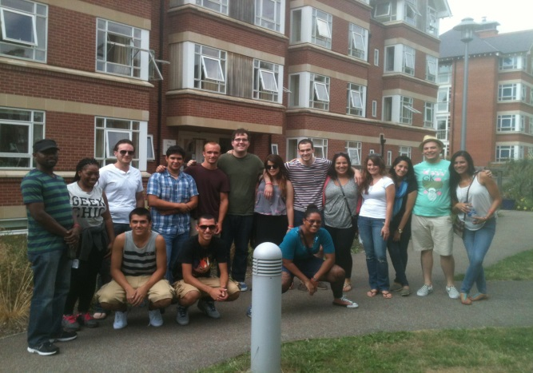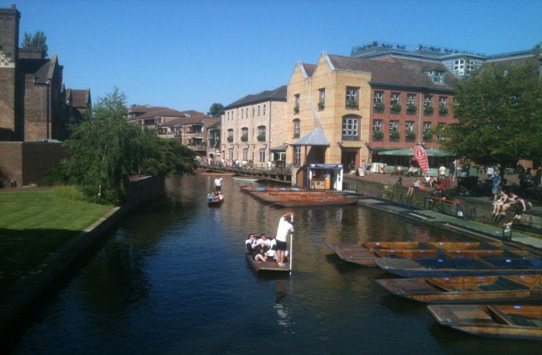
Earn 6 Graduate/Undergraduate Credits in the 15th Annual WPU Summer Program at St. Edmund’s College, Cambridge University
Dates: July 25 – August 17, 2014 St. Edmund’s College is one of 6 graduate colleges at Cambridge University, England and includes students from over 75 nations. Participants have one week of online readings in the U.S., prior to 3 weeks of lectures in the U.K. Assessment includes short discussion papers & final essay exams. (No pre-reqs!)
Costs: Room (single) & Meals (daily) = $1650 Airfare – (approx.) $1000
WPU Tuition – 6 credits (Graduate or Undergraduate)
Deposits - ($1650 cashiers check made out to WPU – covers room and daily meals) will be accepted until April 15, 2014 or the program is filled, whichever comes first.
Courses: Comparative Rights (Prof. Principe – Political Science 302/599) Learn how nations observing both the Common Law System (U.S., U.K., Canada, N.Z.) and the Civil Law System (France, Germany, Italy, Spain) have evolved historically in the protection of political & civil rights (free speech, privacy, equal protection, due process).
Comparative Political Economy (Prof. Snyder – ECON 399/599) This course will focus on the important interaction of economic and political systems across several countries & continents. Students will critically evaluate alternative analytical and theoretical perspectives to better understand how political choices impact economic growth and development, as well as how the world economy alters decisions. Students will then examine some of the major debates in comparative political economy today.
Eligibility: Participants must have completed their freshman year of college and possess a 2.5 gpa. ALL MAJORS ARE WELCOME! Previous participants have included majors from Biology, Business, Education, English, History, Mathematics, Music, Psychology, & Sociology.
Contact: Professor Michael Luis Principe, J.D., Ph.D., WPU Political Science Dep’t & Visiting Fellow, St. Edmund’s College, Cambridge U. principem@wpunj.edu

