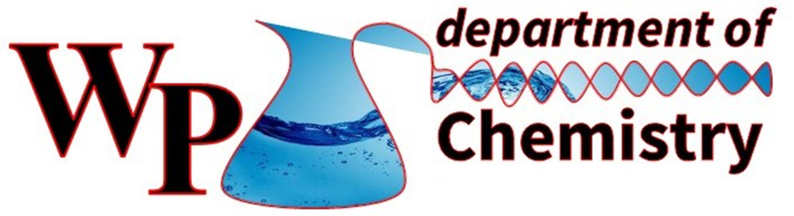
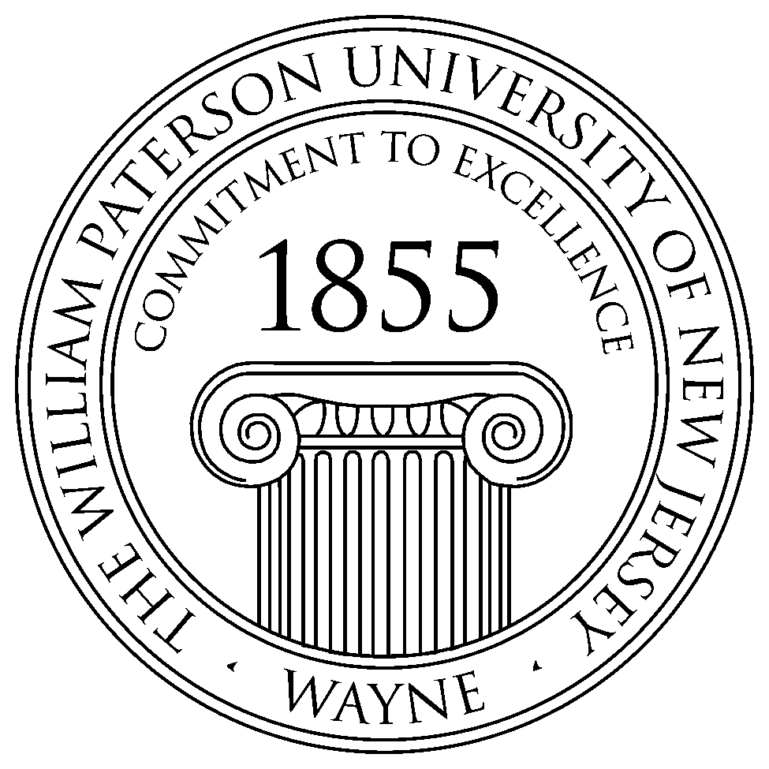

Chemistry Seminar Series
Spring 2016

Time: 12:30-2:00 PM Place: Science Hall West 301

Dr. Garnet Chan
A. Barton Hepburn Professor
Department of Chemistry
Princeton University

When: Thursday, April 21st, 2016
Title: "Recent developments in electronic structure theory”
Prof. Garnet Chan will be discussing a number of recent developments in electronic structure theory, ranging from the accurate treatment of strong correlation, to the computation of structure and spectra in the condensed phase. He will illustrate these developments with examples drawn from bio-inorganic chemistry, semiconductors, and model and realistic high temperature superconductors. As a brief background, Prof. Garnet Chan’s research lies at the interface of theoretical chemistry, condensed matter physics, and quantum information theory, and is concerned with quantum many-particle phenomena and the numerical methods to simulate them. The aim is to understand physical systems at the boundaries of accessible computational complexity, and to devise new physical simulation methods to push these boundaries forward. Over the last decade, his group has contributed to and invented a variety of methods addressing different aspects of quantum simulations, ranging from the challenges of strong electron correlation, to treating many-particle problems in the condensed phase, to dynamical simulations of spectra and coupling between electron and nuclear degrees of freedom.

