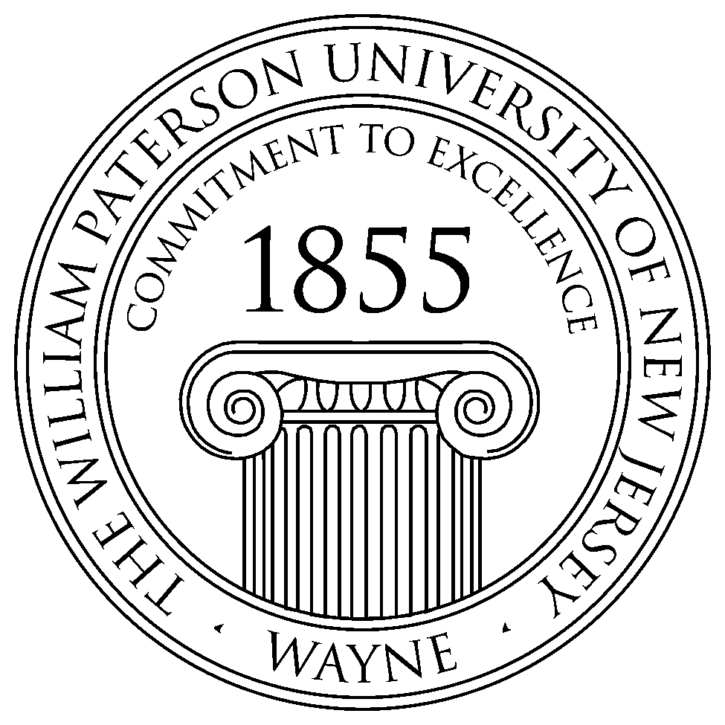

Chemistry Seminar Series
Spring 2016

Time: 12:30-2:00 PM Place: Science Hall West 301
Dr. NAN-LOH YANG
Professor and Chair
Department of Chemistry
Graduate School of CUNY
College of staten island

When: Thursday, February 25th, 2016

“SYNTHETIC NON-HEMOLYTIC AMPHIPHILIC POLYMERS WITH SUPERIOR ANTIBACTERIAL ACTIVITY - A FAMILY OF POTENTIAL ANTI-SUPERBUG AGENTS ”

Synthetic amphiphilic polymers based on the design principles of natural host defense antimicrobial peptides (AMPs) have generated enormous research interest in the last decade due to their cost effective synthesis and structural versatility. The inability of bacteria to gain resistance towards synthetic amphiphilic polymers as opposed to conventional antibiotics has been demonstrated. Our ongoing investigations in the area of synthetic antibacterial polymers have been focusing on polyacrylate systems. Toxicity of the synthetic amphiphilic polymers toward mammalian cells has been a concern, and amphiphilic polymers with potent antibacterial activity and concomitant low hemolytic activity toward mammalian cells are our goals. Our investigations on the antibacterial and hemolytic activities of synthetic amphiphilic polymers focus on the effects of topological placement of hydrophilic and lipophilic structure segments.

