WHAT CAN YOU DO WITH A BACHELORS DEGREE IN PSYCHOLOGY?...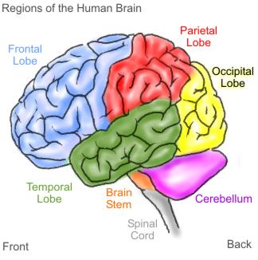

Careers with a B.A. in Psychology
Mental Health
Behavior Analyst
Case Worker
Child Protection Worker
Corrections Officer
Counselor Aide
Day Care Center Supervisor
Director of Volunteer Services
Drug/Substance Abuse Counselor
Employment Counselor
Family Service Worker
Group Home Coordinator
Mental Retardation Unit Manager
Probation/Parole Officer
Program Manager
Rehabilitation Advisor
Residential Youth Counselor
Social Service Director
Veterans' Advisor

Business Area
Administrative Assistant
Advertising Agent
Advertising Trainee
Airline Reservations Clerk
Claims Specialist
Customer Relations
Insurance Agent
Job Analyst
Loan Officer
Management Trainee
Marketing Representative
Marketing Researcher
Personnel Worker/Administrator
Public Information Officer
Public Relations
Sales Representative
Small Business Owner
Store Manager

Other
Affirmative Action Officer
Child Care Worker
College Admissions Counselor
College Admissions Recruiter
Community Recreation Worker
Community Relations Officer
Congressional Aide
Director of Alumni Relations
Director of Fund Raising
Hospital Patient Service Representative
Newspaper Reporter
Park and Recreation Director
Sales Representative
Statistical Assistant
Store Manager
Technical Writer
And so much more….
For more information and some descriptions of what items on the list mean go to
http://www.stats.bls.gov/oco/
http://online.onetcenter.org/
http://www.psywww.com/careers/entry.htm
http://www.apa.org/careers/index.aspx

Psychology Department
2061 Science Hall
Office hours:
Fall and Spring 8:30-4:30
Summer 8:00-5:15
(973) 720-2148

