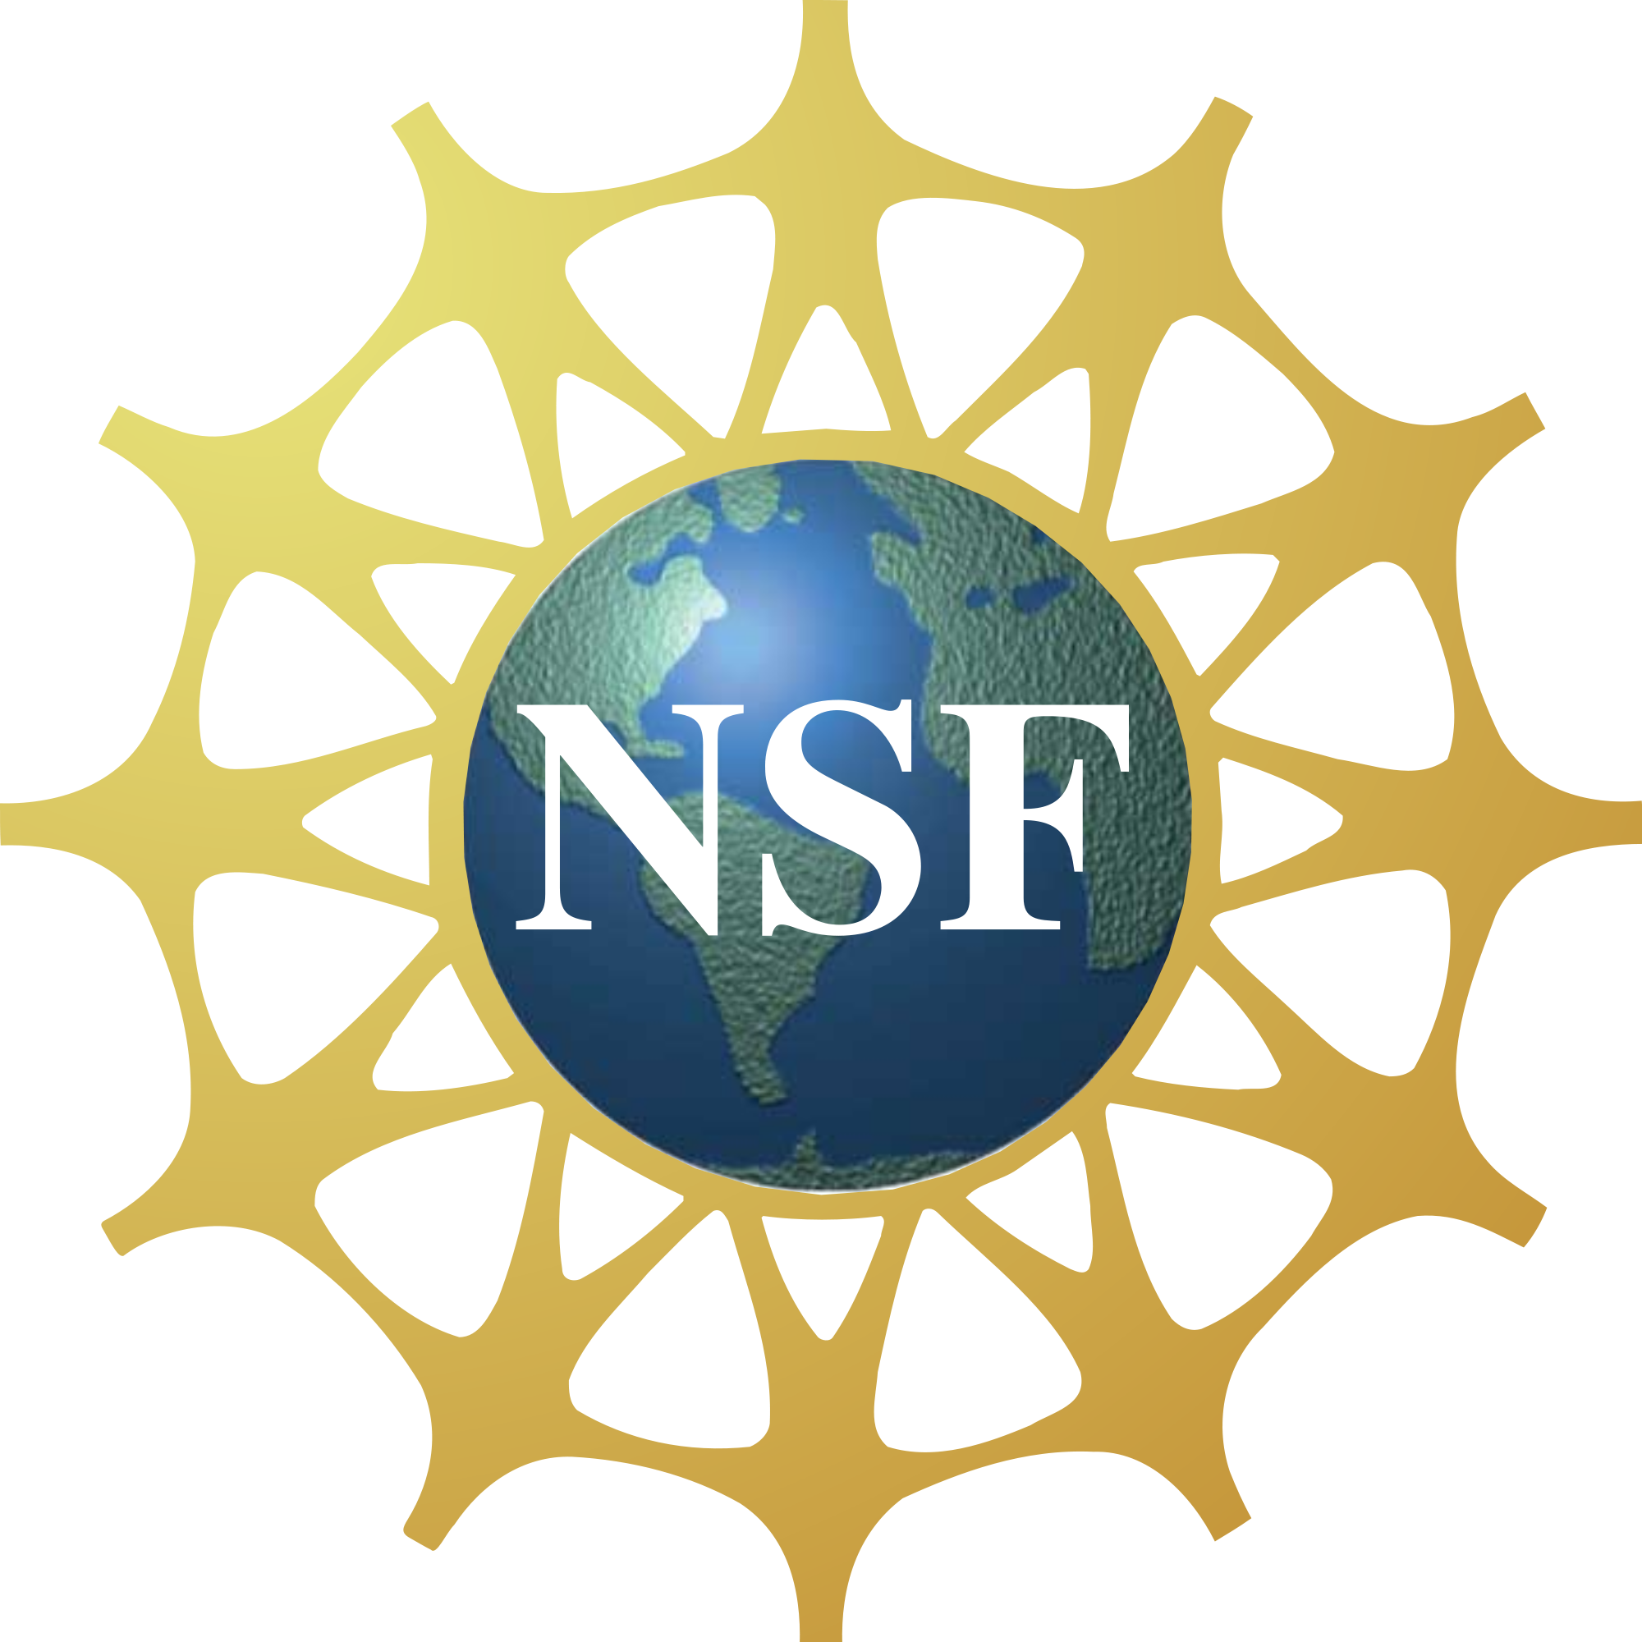
ROBERT NOYCE

TEACHER SCHOLARSHIP PROGRAM
FUNDED BY THE NATIONAL SCIENCE FOUNDATION
  - INSTRUCTIONS
  - Eligibility:
- U.S. citizen, national, or permanent resident alien at the time of application.
- Mathematics / Science major, along with Education as a double major at William Paterson University.
- Completion of at least 60 credits, with at least 15 credits towards the Mathematics / Science major.
- Overall Grade Point Average (GPA) of 3.0 at WPUNJ. Transfer students should have a 3.0 from their transfer institution.
- Completed and filed a Free Application for Federal Student Aid (FAFSA) with the Financial Aid Office.

  - Requirements:
- You must participate in NOYCE related surveys and interviews throughout your scholarship and committed teaching years.
- Upon completion of your degree, you are required to teach for two years (in a high-needs school district) for each year of scholarship support.
For a list of schools that qualify as high-need, please visit the Annual Directory of Designated Low-Income Schools for Teacher Cancellation Benefits. (URL: https://www.tcli.ed.gov/CBSWebApp/tcli/TCLIPubSchoolSearch.jsp)

  - Application Process:
You are required to electronically submit the following:
- Completed scholarship application form (Page 2).
- Documentation of citizenship status (photocopy or scan of passport, birth certificate, permanent resident card, etc.)
- ONE letter of recommendation from a faculty member who taught you science or math addressed to the Robert Noyce Teacher Scholarship Committee.
- A short personal statement (no more than 1 typed page) outlining your goals, educational plans and how these relate to working in a high needs school.

Only applications accompanied by all supporting documents will be given full consideration.

Scholarships are renewable for up to two years, if the student maintains a minimum GPA of 3.0 and upon availability of funds.
For questions / application submission, email: Dr. Djanna Hill or Dr. Jyoti Champanerkar

ROBERT NOYCE

TEACHER SCHOLARSHIP PROGRAM
FUNDED BY THE NATIONAL SCIENCE FOUNDATION

  - Scholarship Application Form

Name: ID Number: 855

Date of Birth: Current Status: Full time / Part time (Circle one.)

Street Address: Town:
State: Zip:

Home Phone Number: Cell Phone Number:

Email: Alternate Email:

STEM Major: Biology / Chemistry / Computer Science / Environmental Science /
Integrated math & Science / Mathematics (Circle one.)

Education Major: P-3 and K-6 / K-6 / K-6 with 5-8/ K-6 with TSD / K-12 / K-12 with TSD

Overall GPA: Anticipated Date of Graduation from WPUNJ: _______________

Awards/ Recognition (Include dates for Scholarships, Dean's List, etc.):

Community Activities (include dates):
Extracurricular Activities (Include dates, name of organization / team, position held):

Work Experience:

Additional Pertinent Information:

Please use additional sheets if needed.
For questions / application submission, email: Dr. Djanna Hill or Dr. Jyoti Champanerkar

